Connecting to github using SSH:

First you need to create ssh in your PowerShell. The command is:

ssh-keygen -t rsa

You can just press enter for the remaining questions:

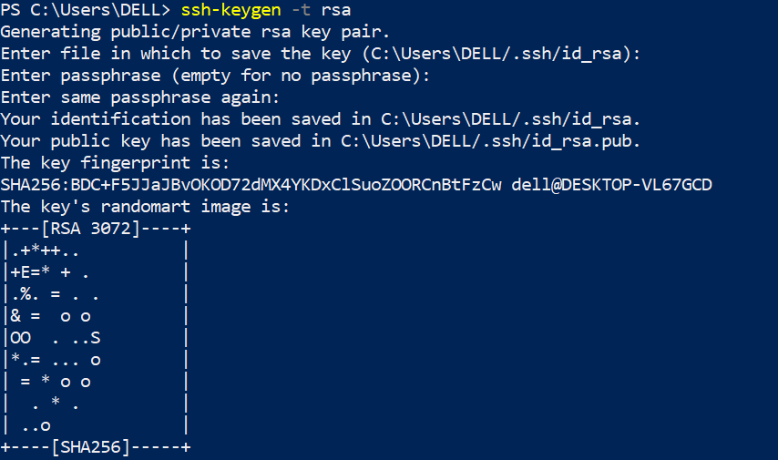

Then you can grab your ssh key by using:

cat “directory of the file”

For example for me is cat C:\Users\DELL/.ssh/id_rsa.pub

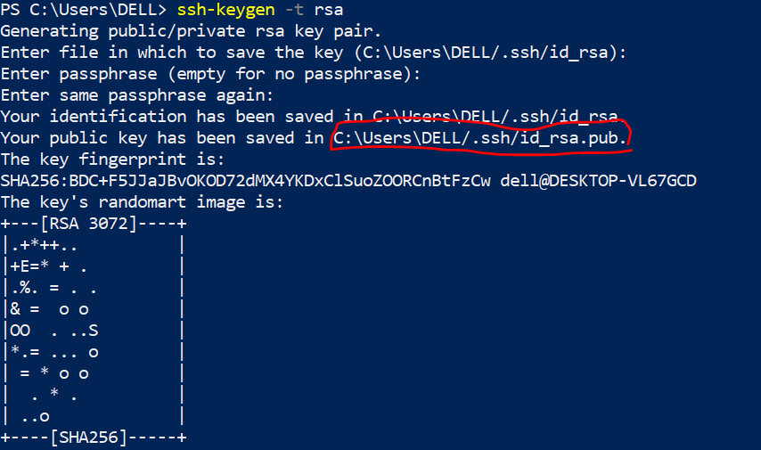

You can see the full ssh key here:



Now its time to go to github account to add ssh:  


From menu item on top right you need to go to the setting:

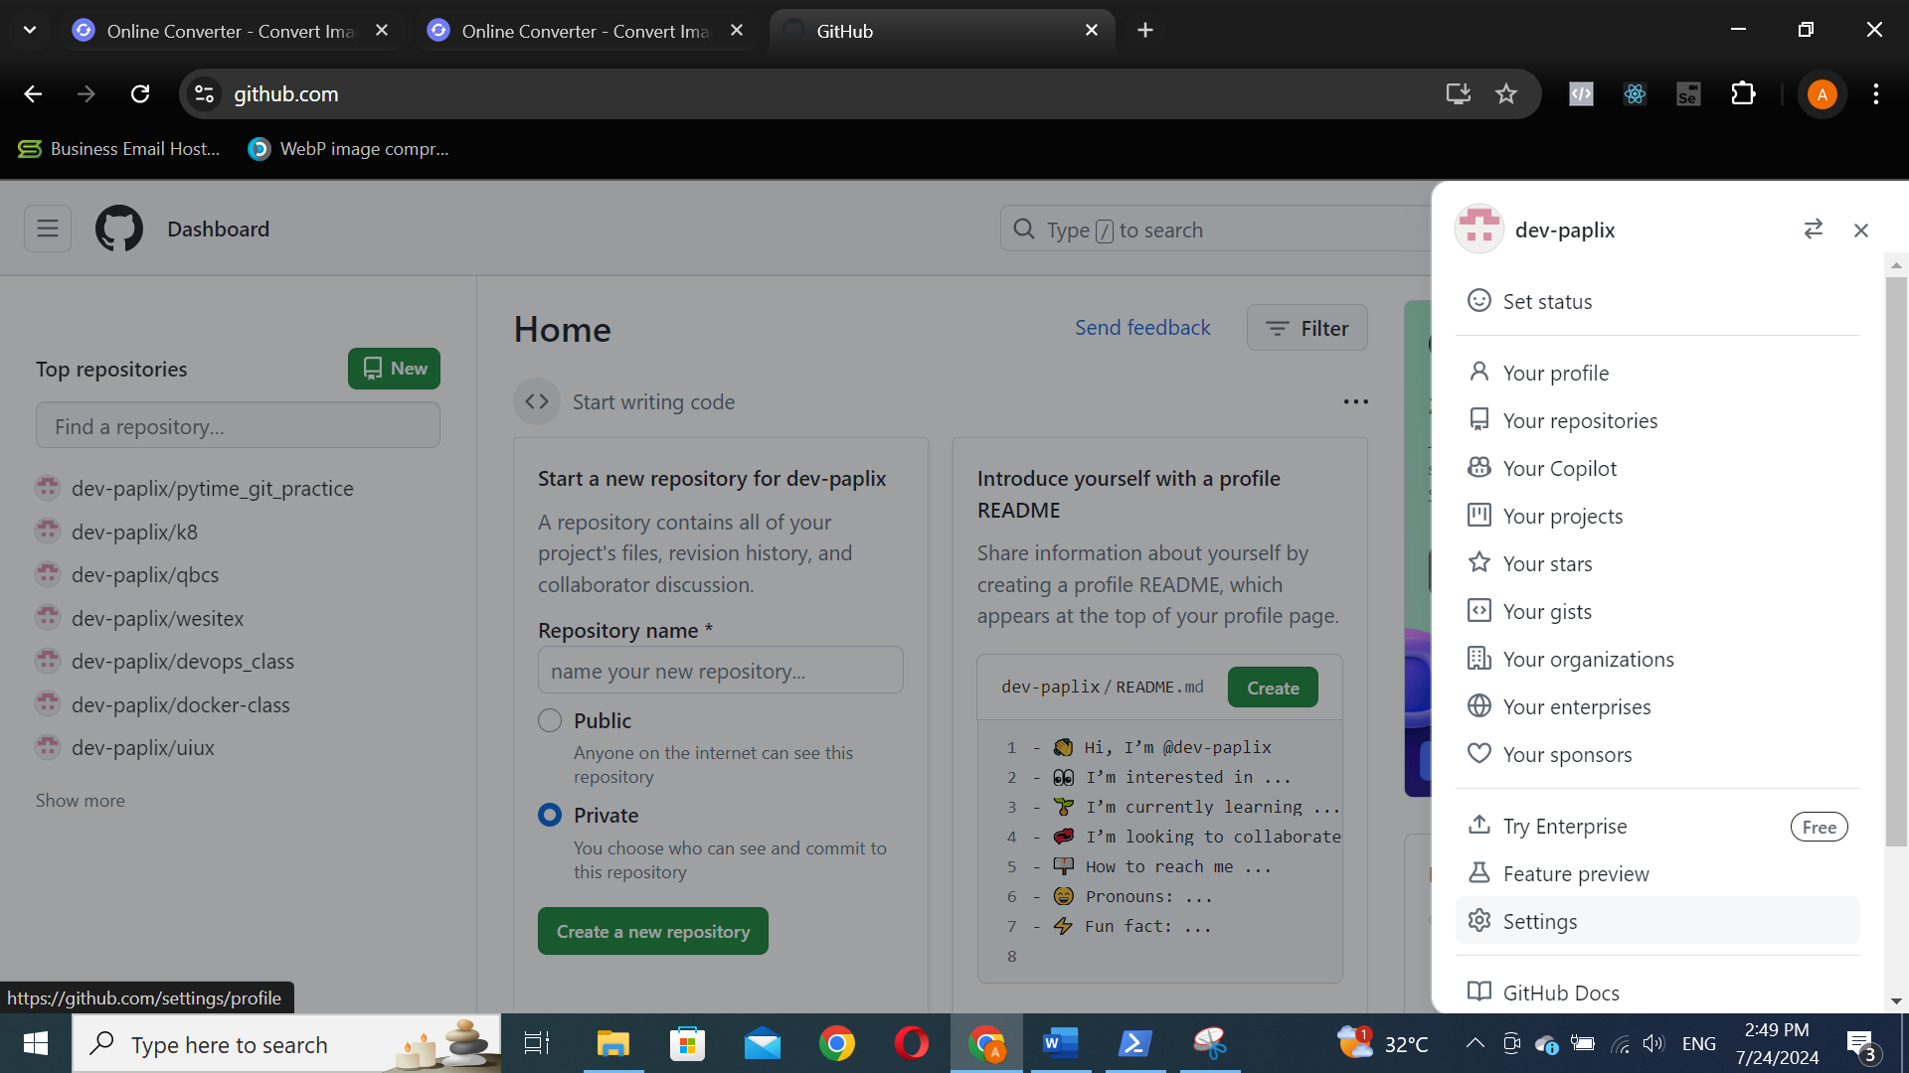

You have to choose SSH and GPG key from the left menu:



In the left side of the screen you need to click on New SSH key green button:

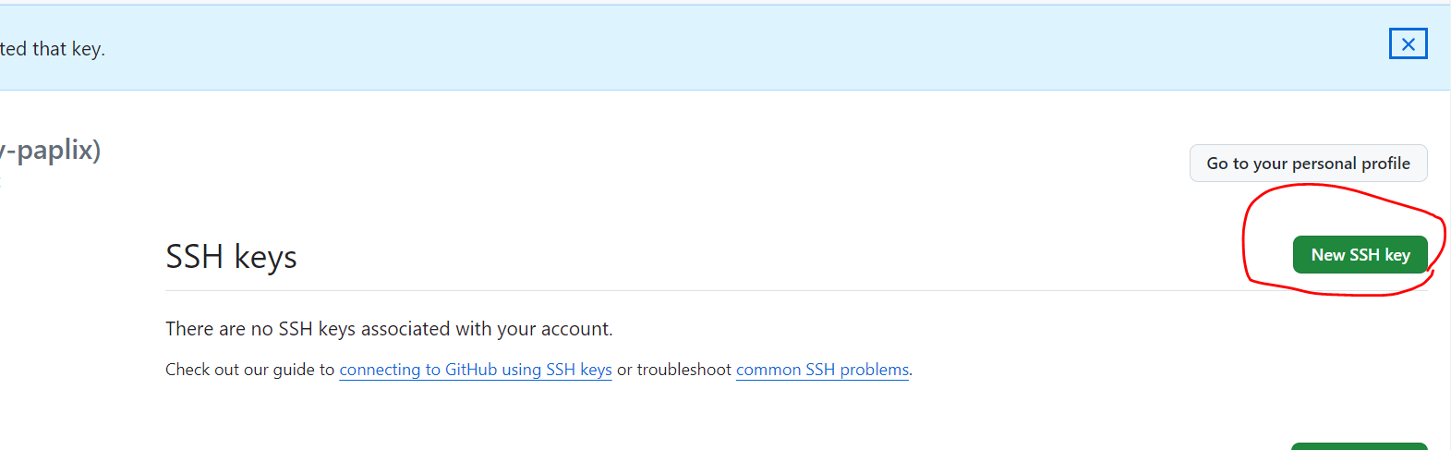

Now in the key section you need to copy the generated ssh key from the PowerShell, feel free to give whatever title to the key you want and finally press green Add SSH key, it might ask for github password for the security purposes:

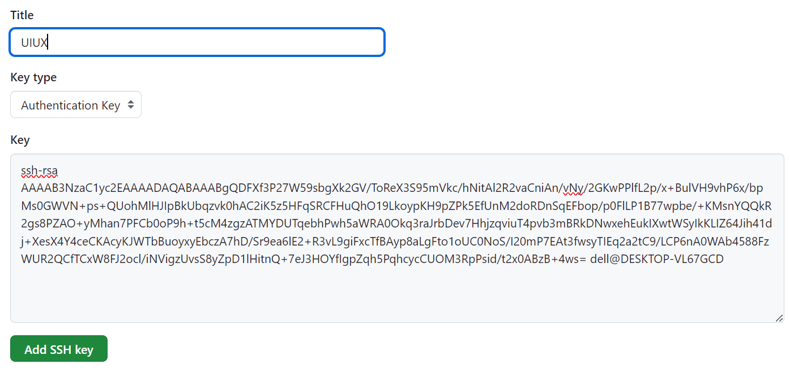

To check the whether the connection is established or not you can use the following command, it might ask you for extra authentication which you need to answer yes:

ssh -T [git@github.com](mailto:git@github.com)



Here we can see the exact username of the our Github is shown, which means the local device is connected to our Github account.